What Not to Ask When Communicating with an Owner about Damage to Furniture
Objective
To provide a clear and effective process for notifying property owners about tenant-caused damages and determining the appropriate course of action.
Key Steps

1. Identify Damage 0:15
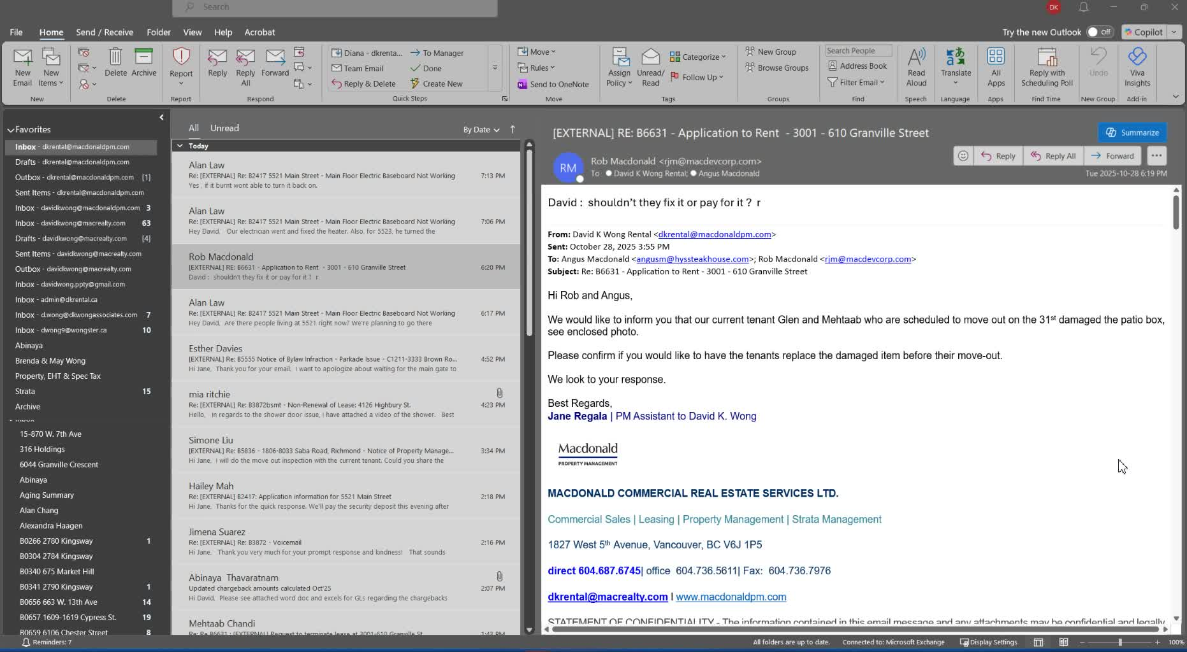
- Visit the property to assess any reported damages.
- Document the specific damage observed (e.g., patio box damage).

2. Notify the Owner 0:46
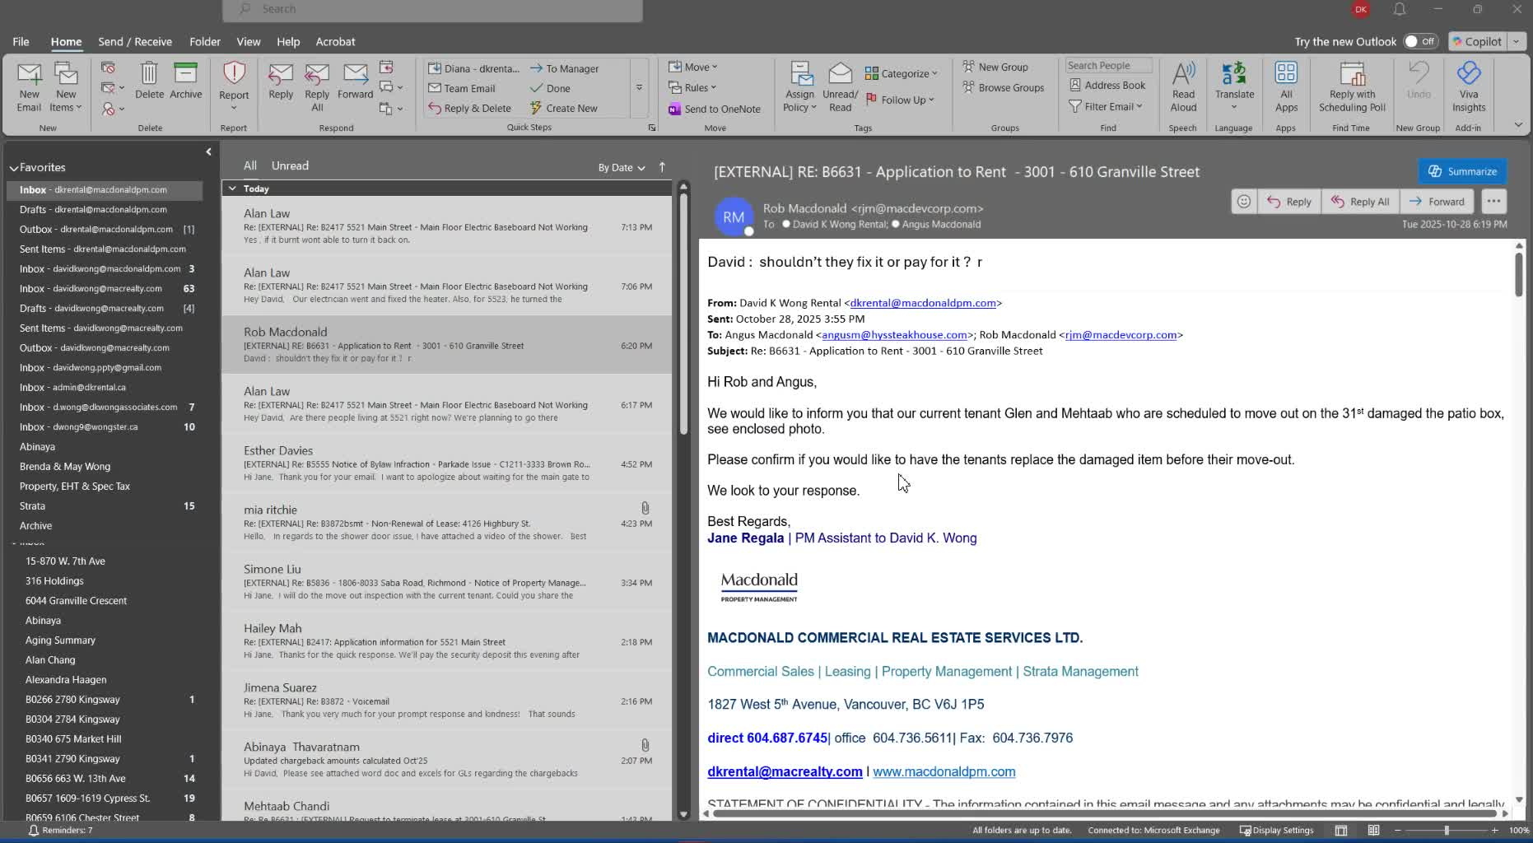
- Inform the property owner about the damage without asking for their opinion.
- Clearly state that the damage occurred and needs to be addressed.

3. Determine Replacement Costs 1:29
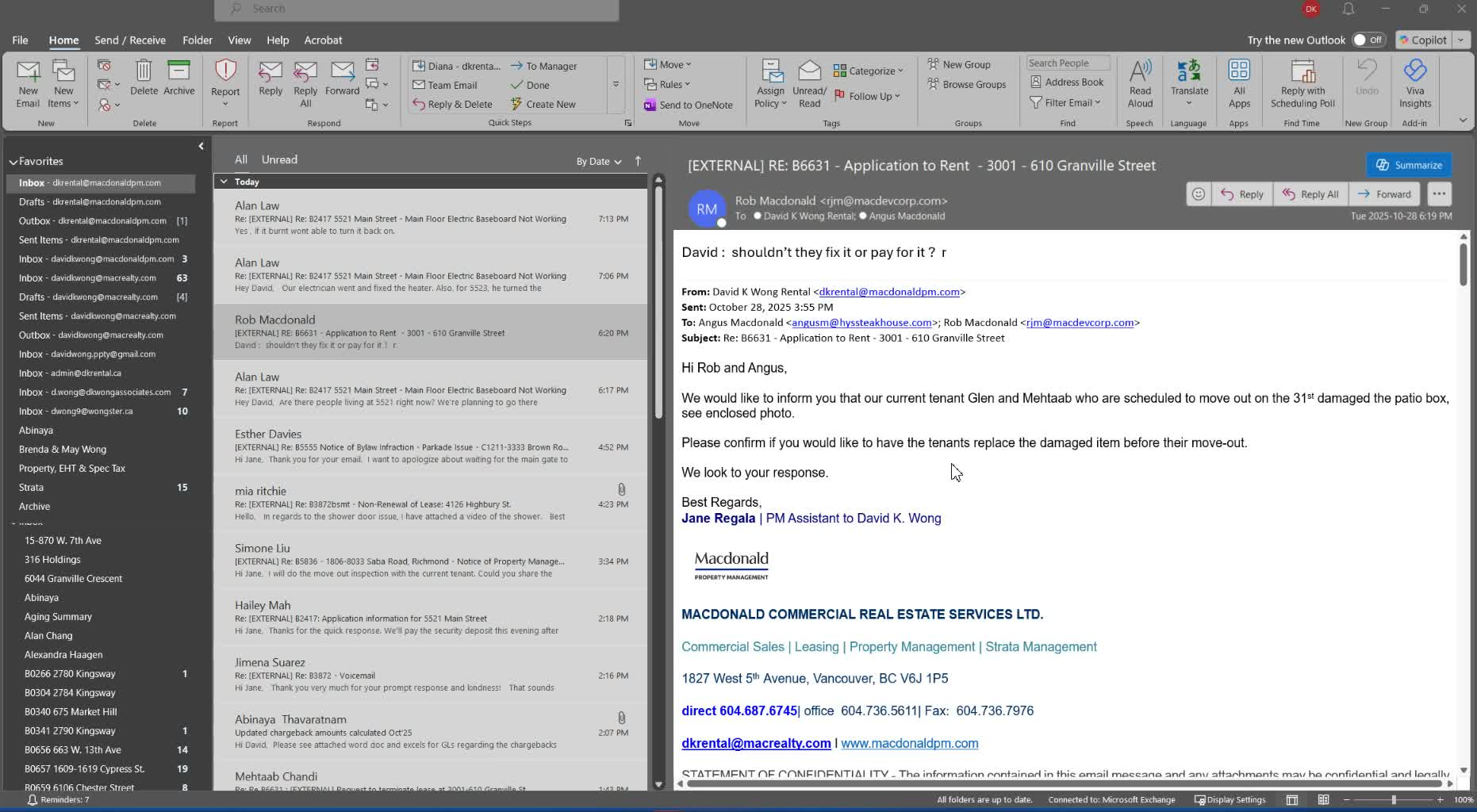
- Ask the owner for the cost of the damaged item (e.g., how much was the patio box?).
- Ensure to gather information on where the item was purchased.

4. Charge Security Deposit 2:57
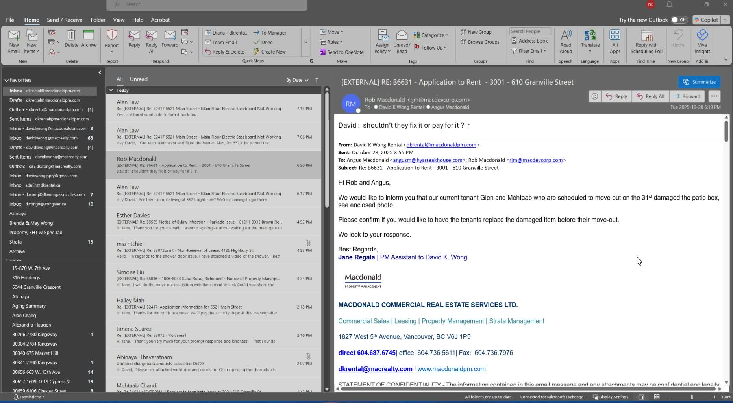
- Once the cost is confirmed, deduct the amount from the tenant's security deposit.
- Ensure that any charges are justifiable with an invoice.

5. Communicate Clearly 4:49
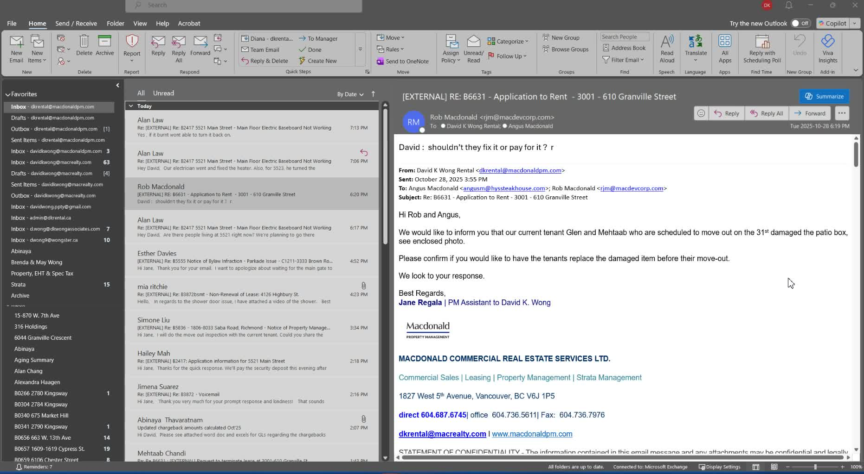
- Avoid open-ended questions that require the owner's opinion on repairs.
- Be direct in communication: state the damage, the cost, and the action to be taken.

6. Follow Up 5:03
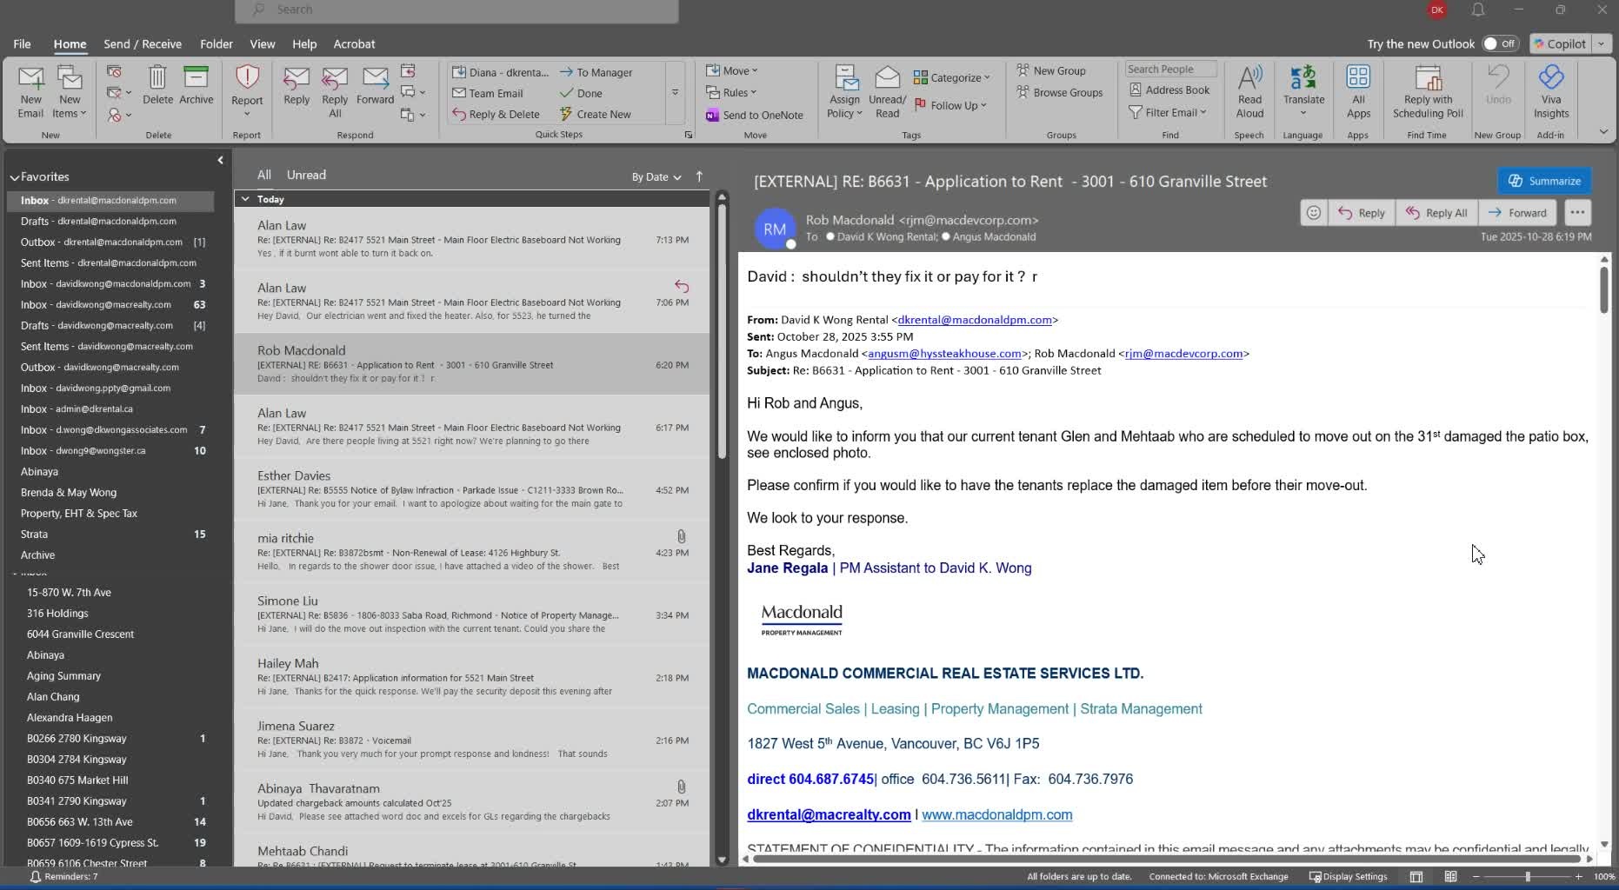
- If an invoice is available, provide it to the owner for transparency.
- Keep the owner updated on the status of repairs and any further actions.
Cautionary Notes
- Avoid asking for the owner's permission regarding repairs; it can lead to confusion and frustration.
- Ensure all communications are clear and direct to prevent misunderstandings.
Tips for Efficiency
- Always document damages with photos and notes during property visits.
- Maintain a list of common repair costs for quick reference.
- Use templates for communication to streamline the process.
Link to Loom
https://loom.com/share/5d73d2495d834a238d185222c052897b

Improving Communication with Property Owners Regarding Damages

1. Identify the Damage 0:00
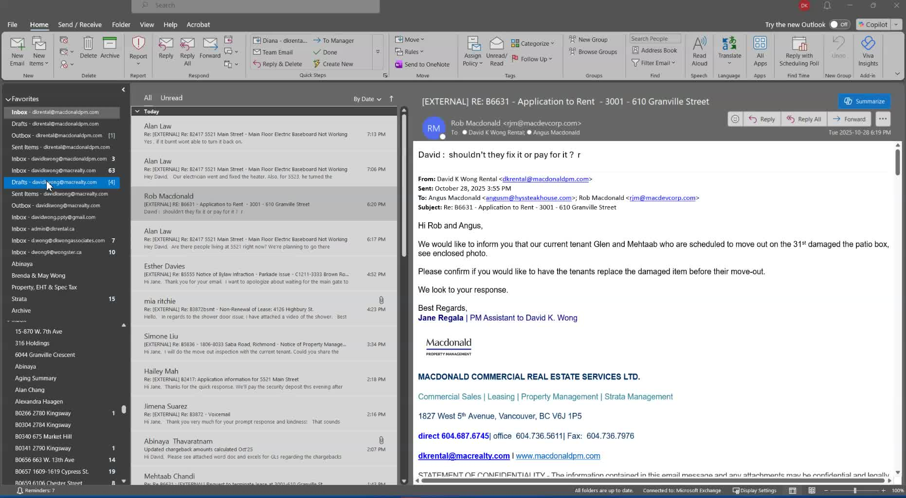
- Observe and document any damage to the property (e.g., patio box).
- Notify the owner about the damage.

2. Clarify the Responsibility 0:15

- Understand that the tenants are responsible for the damage they caused.
- Avoid asking for the owner's opinion on whether to replace or repair the damaged item.

3. Ask the Right Questions 1:07
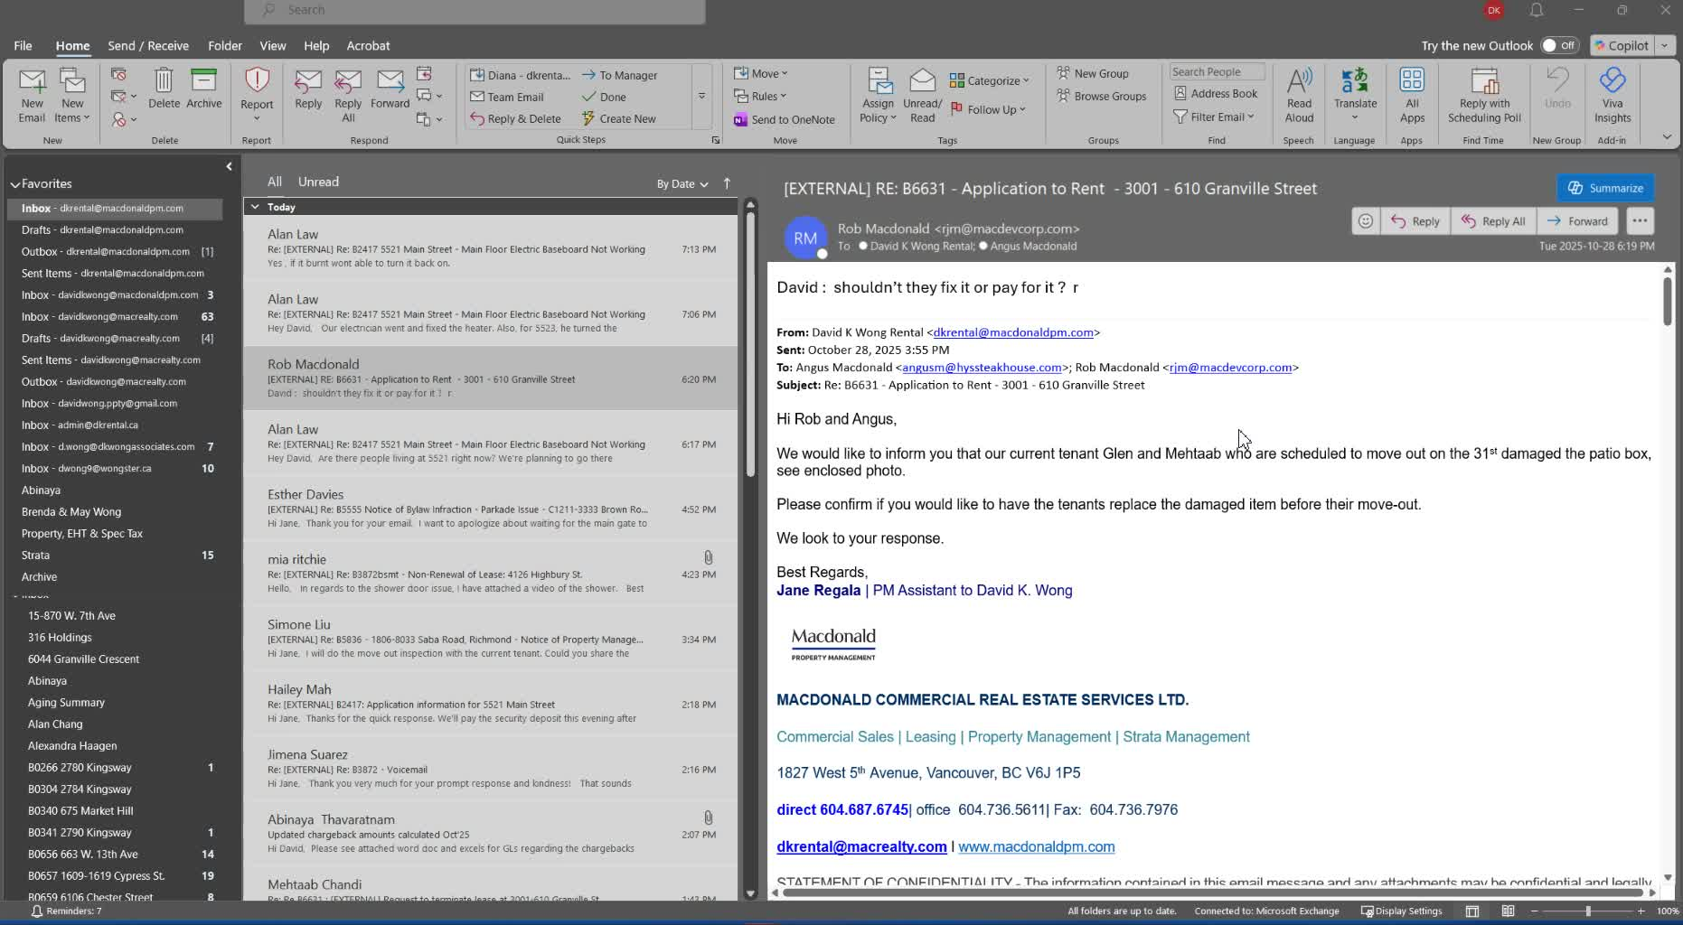
- Instead of asking if the owner wants the tenants to replace the item, ask:
  - "How much was the damaged item?"
  - "Where did you purchase it?"
- This helps determine the cost for charging back the security deposit.

4. Provide Clear Instructions 2:36
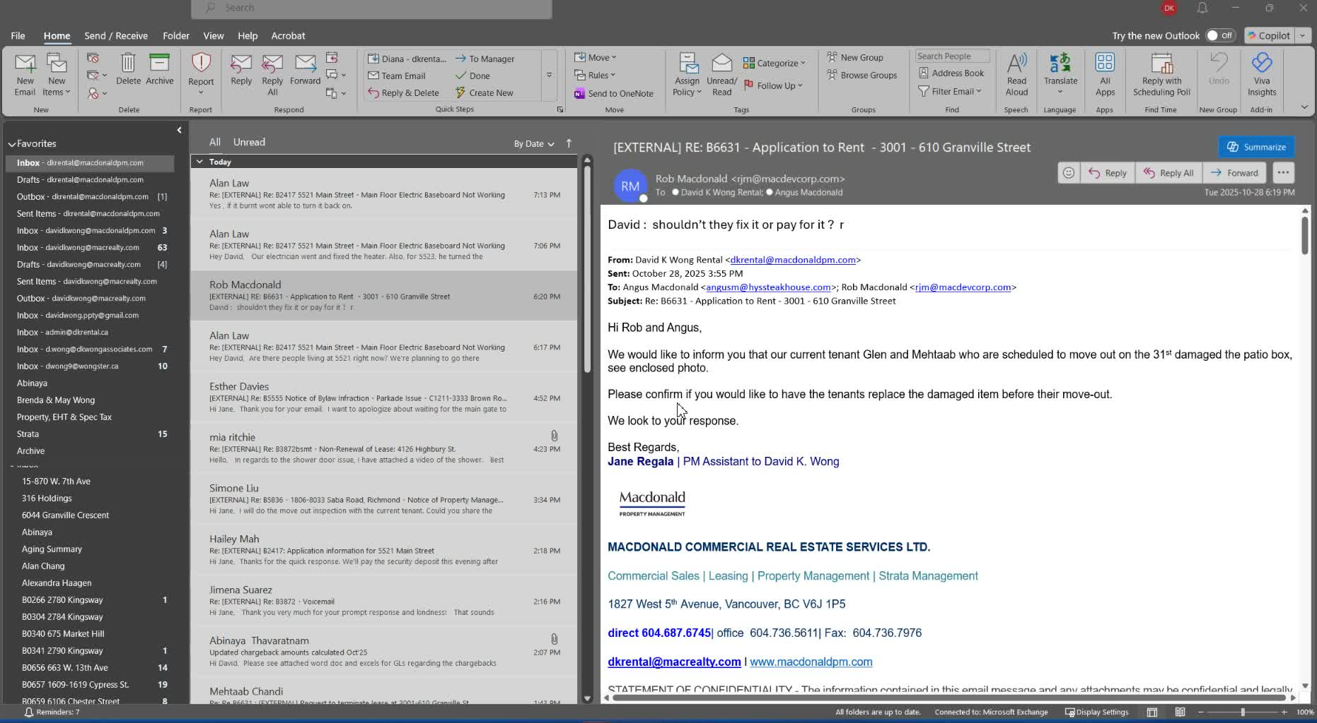
- Communicate clearly to the owner that the damaged item needs to be replaced.
- Avoid open-ended questions that could lead to confusion or frustration.

5. Justify the Costs 3:38
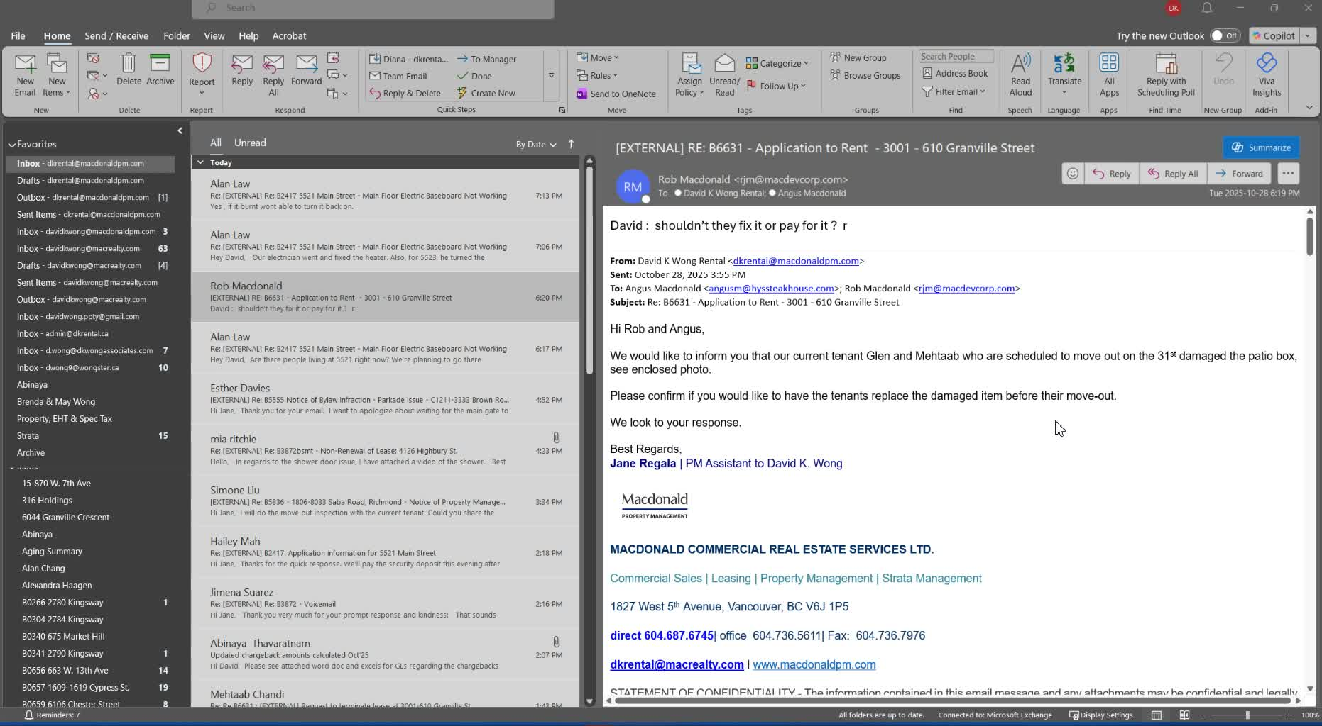
- Ensure that any charges to the security deposit are justifiable with an invoice or quote.
- Provide options for repairs to the owner, similar to previous cases.

6. Avoid Unnecessary Confusion 4:41
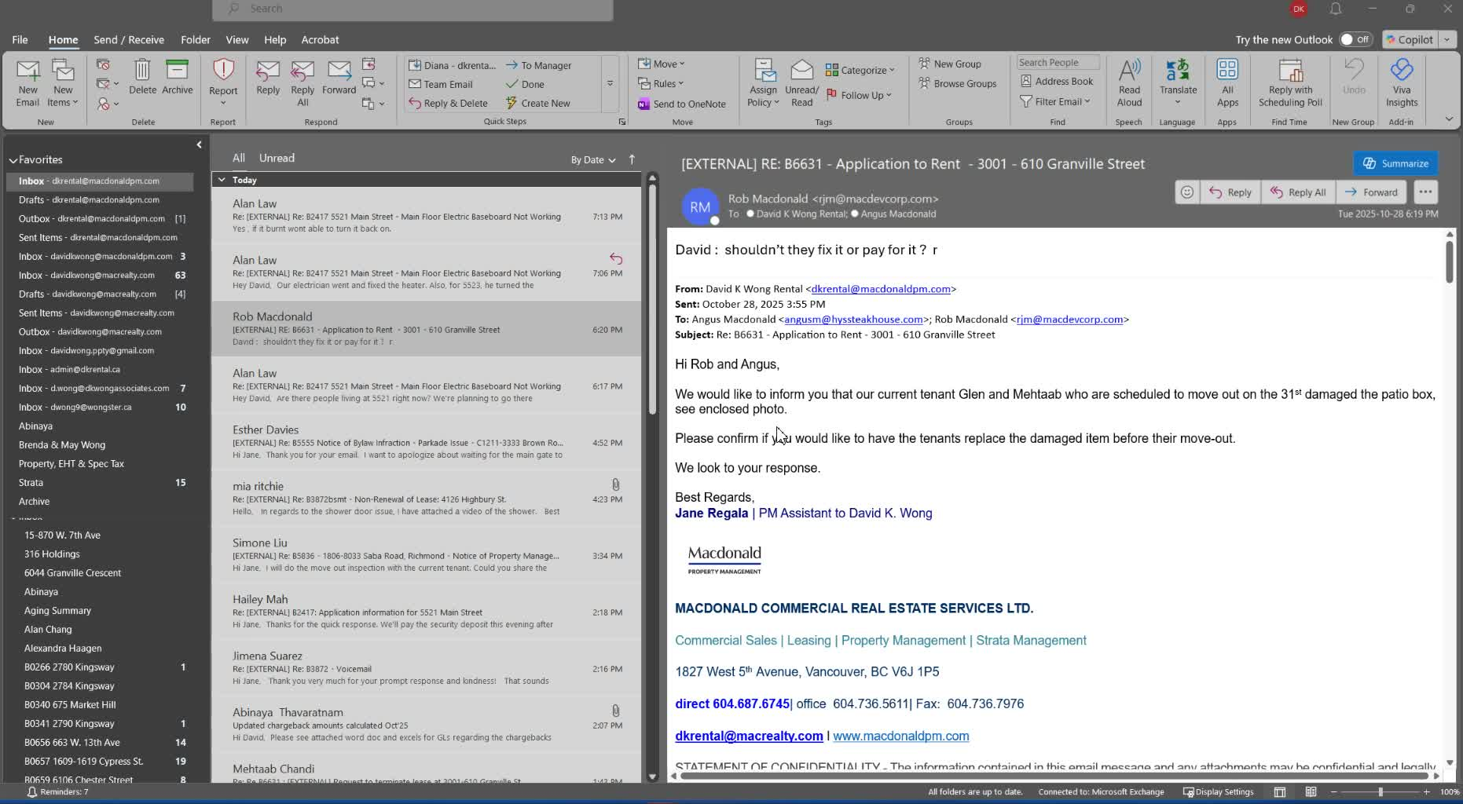
- Do not ask for confirmation on actions that are clearly the tenant's responsibility.
- Focus on direct communication and clear instructions to prevent misunderstandings.

7. Follow Up on Costs 5:03

- If unsure about the cost of repairs, ask the owner for the necessary information.
- Ensure that all communication is straightforward and focused on resolving the issue.
Link to Loom
https://loom.com/share/5d73d2495d834a238d185222c052897b
Steps to Reproduce Bug in Communication with Property Owner

1. Identify the Damage 0:15

- Visit the property to inspect for any damage.
- Note any specific issues, such as damage to the patio box.

2. Notify the Owner 0:46

- Inform the owner (e.g., Rob McDonald) about the damage.
- Clearly state that the damage occurred and does not require permission to fix.

3. Ask for Replacement Cost 1:29

- Instead of asking for the owner's opinion on repairs, ask:
  - "How much was the patio box?"
  - "Where did you purchase it?"

4. Determine Repair Responsibility 4:24

- Clarify that the tenant is responsible for the damage.
- Do not ask if the owner wants to replace it; state that it needs to be replaced.

5. Obtain Invoice for Charges 3:38
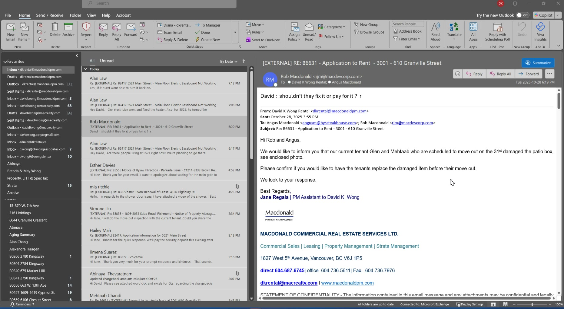
- Ensure that any charges to the tenant are backed by an invoice.
- This is necessary for justifying deductions from the security deposit.

6. Improve Communication 4:49

- Focus on direct communication with the owner.
- Avoid open-ended questions that may lead to confusion or dissatisfaction.
Link to Loom
https://loom.com/share/5d73d2495d834a238d185222c052897b
0:00 Just want to uncover a situation here for 6631. You'll see that Rob McDonald, the owner of, 3001610 Gravel, is responding back to, an email just based on my observation today.
0:15 I went to the property to look at, you know, the, the, the work servicing on the blinds and, notified that, I noticed some damage to the patio box or what you want to call it for the patio.
0:28 And so how do we respond to these things is really important because what what the question and I'm just gonna look this this is past.
0:38 What we're trying to do here is not ask for their opinion. Yeah, so just look at this very clearly. So this is fine.
0:46 Notifying Rob, damage. Okay, so that's, that's fine. However, please confirm you would like to have the tenants replaced. It's not even a question.
0:55 They damaged it. We don't need to ask permission, if you would want them to. What we're trying to do here and basically Rob is right, should they fix it or pay?
1:07 There's no point fixing it because unless you have a cover for that thing. It's needs to be replaced or we recover money from them.
1:15 So what would be in the better way to ask is notifying them that that was damaged. How much was that box is the question that we need to replace it because it's just plastic.
1:29 It's just a plastic box. And so the point would be Angus or Rob. How much was it? And then we would just deduct that amount from the, security deposit because asking please confirm if you'd like to have the test like obviously it's a no-brainer this is not even a question we should be asking the government
1:50 the owner if the owner came back so forget about it. We don't really need to worry about it. That's fine.
1:57 Rob is now in a very antsy position because we had to just, you know, after 10 years of not paying anything for 3015 or 14.
2:09 He's has a bit of a beef with us. That's too bad because we've been managing all those his properties for a long, long time and really never made any money.
2:18 So now he's just saying, shouldn't they fix or pay for it? The answer is yes Rob and instead of us getting him at this irate attitude we should have said and this is why I'm covering this that you need to understand how to ask a better question.
2:36 You ask him to confirm if this is okay. No, it's not okay. The bottom line, they broke it. Not okay.
2:43 We need to replace it or how much was it? So you're getting the owner to tell us how much it was.
2:52 So for us to replace it, it's going to be, I don't know, 400 bucks. I don't know what the cost is.
2:57 It's plastic all right doesn't matter. It's also being used. So there's gonna be a certain value to these things my question would be How much was it and Where'd you buy it?
3:10 From so we know how much to charge back the security deposit That's the better answer. This would have been not the question.
3:19 He would be asking he would then say to Angus or angus would have came back or even rob would have came back and said this is how much it costs or just in best case scenario Charge him 500 bucks and we're done And we can't just charge him 500 bucks because we have to have an invoice for it So these kind
3:38 of things need to be justifiable. At the same time, I'm trying to focus on how do we improve our communication to the owner because that last part isn't okay.
3:49 It's basically open-ended Asking him for his opinion. This is not for opinion. They damage something. They have to repair it No difference when Aaron damaged the floor.
4:00 He's repairing it. How much is gonna cost is to be determined However, we do have a quote. That's what we need to do.
4:07 That's what we have done for the owner of Phillip when we Identified the ceiling issue. We identified the flooring issue.
4:15 We're giving him some options But this is what we're doing. It's getting repaired. That's the responsibility of the tenant who damaged something.
4:24 Don't ask if we want to confirm that they want it to replace before they move on. That's not the right, question.
4:32 This is the response you'll get and they're not happy. So this is what needs to happen. Think about what you're gonna say if you don't know what you're gonna ask.
4:41 Don't do this. Don't do this. I've seen this too many times. We got to stop this type of nonsense because that is not okay.
4:49 We need to make sure we know how to directly give instruction to an owner. This is what's happening. This is how much we need.
4:57 How much is it gonna be owner? We don't know how much it is That's the better question ask the owner.
5:03 The owner is gonna say this is how much it is if Angus has got An invoice for beautiful He can provide it.

